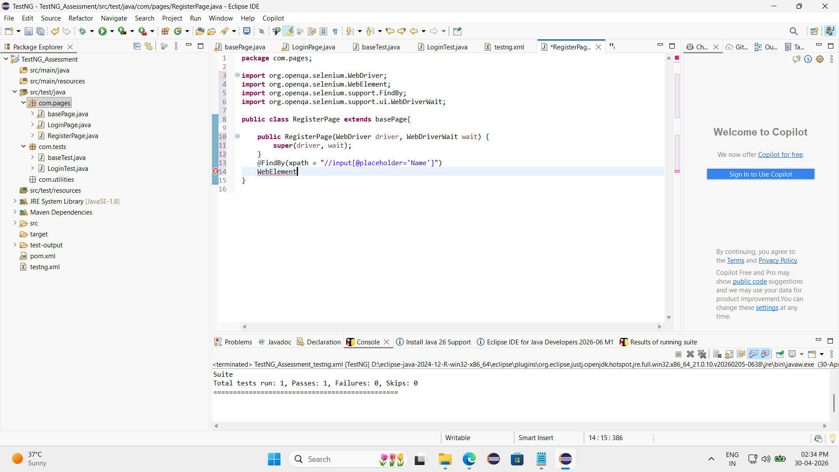

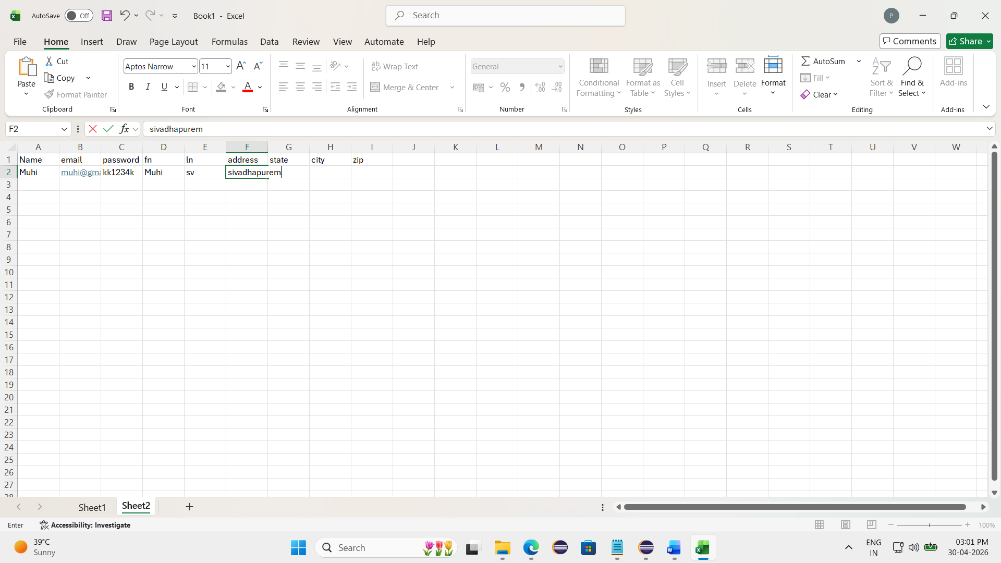

[RemoteTestNG] detected TestNG version 7.12.0
SLF4J(W): No SLF4J providers were found.
SLF4J(W): Defaulting to no-operation (NOP) logger implementation
SLF4J(W): See https://www.slf4j.org/codes.html#noProviders for further details.
PASSED: com.tests.RegisterTest.register

===============================================
Default test
Tests run: 1, Failures: 0, Skips: 0
===============================================

===============================================
Default suite
Total tests run: 1, Passes: 1, Failures: 0, Skips: 0
===============================================

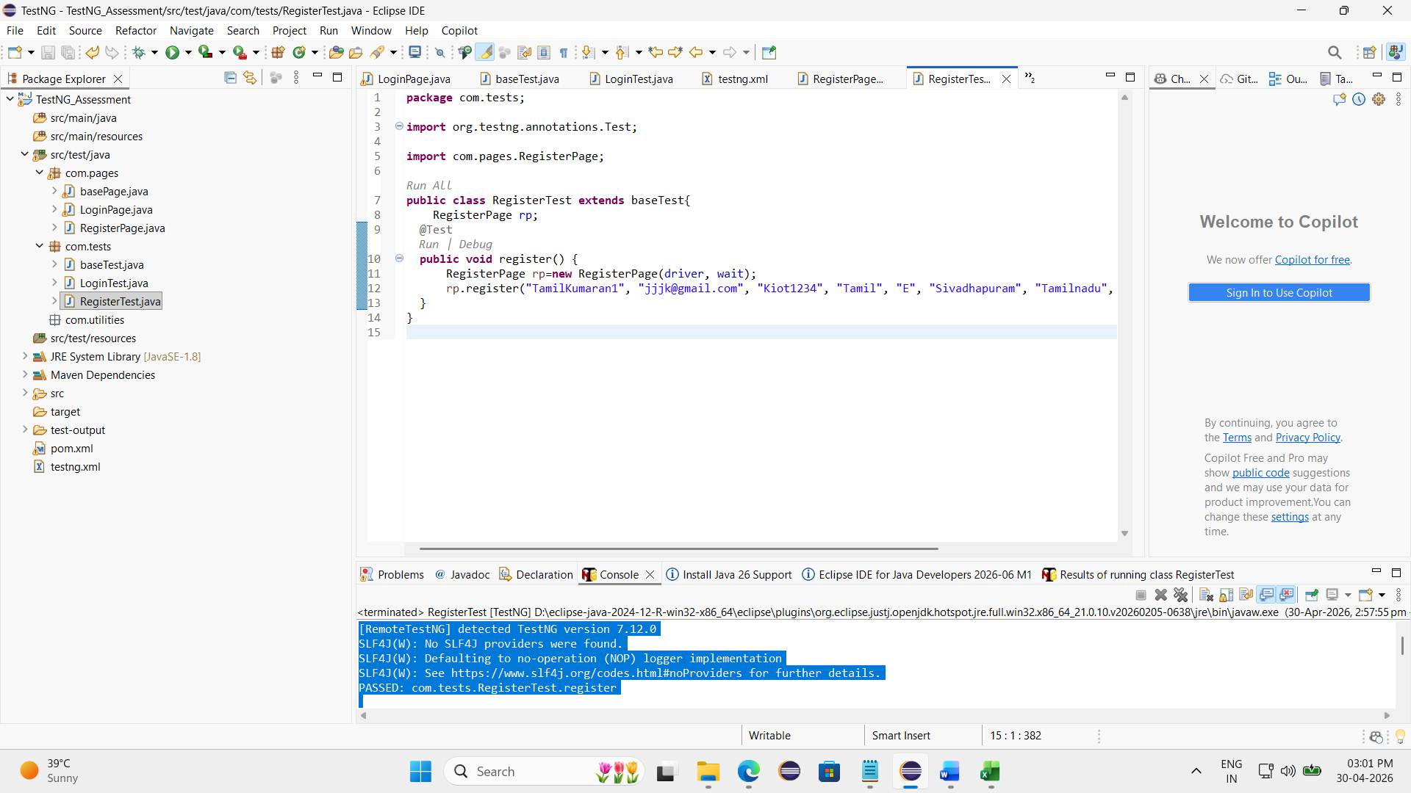

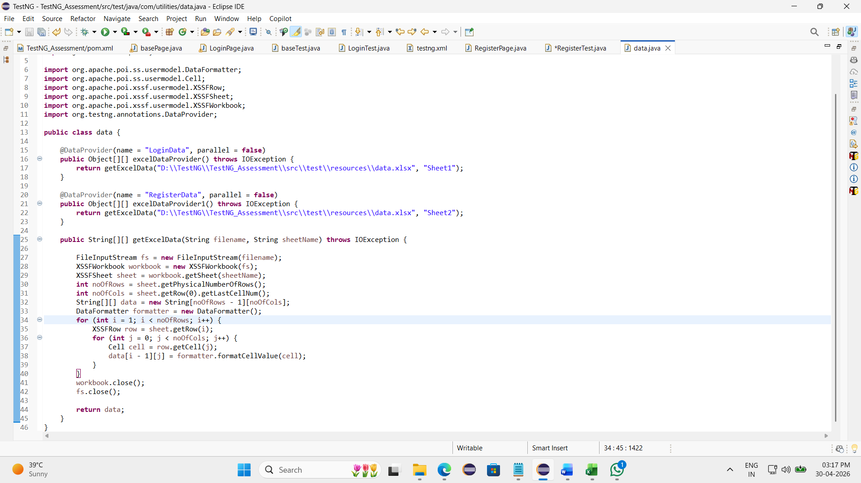

[RemoteTestNG] detected TestNG version 7.12.0
SLF4J(W): No SLF4J providers were found.
SLF4J(W): Defaulting to no-operation (NOP) logger implementation
SLF4J(W): See https://www.slf4j.org/codes.html#noProviders for further details.
FAILED: com.tests.RegisterTest.register("Muhi", "kwdmf@gmail.com", "kk1234k", "Muhi", "sv", "sivadhapurem", "Tamilnadu", "salem", "345678")
org.openqa.selenium.NoSuchWindowException: no such window: target window already closed
from unknown error: web view not found
(Session info: chrome=147.0.7727.117)
Build info: version: '4.43.0', revision: 'dd0f534'
System info: os.name: 'Windows 11', os.arch: 'amd64', os.version: '10.0', java.version: '21.0.10'
Driver info: org.openqa.selenium.chrome.ChromeDriver
Command: [910641ef669566c3cd1820c5594a8641, findElement {using=xpath, value=//a[normalize-space()='Signup / Login']}]
Capabilities {acceptInsecureCerts: false, browserName: chrome, browserVersion: 147.0.7727.117, chrome: {chromedriverVersion: 147.0.7727.117 (474cc805edd..., userDataDir: C:\Users\tamil\AppData\Loca...}, fedcm:accounts: true, goog:chromeOptions: {debuggerAddress: localhost:54677}, goog:processID: 4028, networkConnectionEnabled: false, pageLoadStrategy: normal, platformName: windows, proxy: Proxy(), se:cdp: ws://localhost:54677/devtoo..., se:cdpVersion: 147.0.7727.117, setWindowRect: true, strictFileInteractability: false, timeouts: {implicit: 0, pageLoad: 300000, script: 30000}, unhandledPromptBehavior: dismiss and notify, webauthn:extension:credBlob: true, webauthn:extension:largeBlob: true, webauthn:extension:minPinLength: true, webauthn:extension:prf: true, webauthn:virtualAuthenticators: true}
Session ID: 910641ef669566c3cd1820c5594a8641
at org.openqa.selenium.remote.ErrorCodec.decode(ErrorCodec.java:169)
at org.openqa.selenium.remote.codec.w3c.W3CHttpResponseCodec.decode(W3CHttpResponseCodec.java:142)
at org.openqa.selenium.remote.codec.w3c.W3CHttpResponseCodec.decode(W3CHttpResponseCodec.java:49)
at org.openqa.selenium.remote.HttpCommandExecutor.execute(HttpCommandExecutor.java:223)
at org.openqa.selenium.remote.service.DriverCommandExecutor.invokeExecute(DriverCommandExecutor.java:216)
at org.openqa.selenium.remote.service.DriverCommandExecutor.execute(DriverCommandExecutor.java:174)
at org.openqa.selenium.remote.RemoteWebDriver.execute(RemoteWebDriver.java:606)
at org.openqa.selenium.remote.ElementLocation$ElementFinder$2.findElement(ElementLocation.java:166)
at org.openqa.selenium.remote.ElementLocation.findElement(ElementLocation.java:60)
at org.openqa.selenium.remote.RemoteWebDriver.findElement(RemoteWebDriver.java:429)
at org.openqa.selenium.remote.RemoteWebDriver.findElement(RemoteWebDriver.java:423)
at org.openqa.selenium.support.pagefactory.DefaultElementLocator.findElement(DefaultElementLocator.java:68)
at org.openqa.selenium.support.pagefactory.internal.LocatingElementHandler.invoke(LocatingElementHandler.java:38)
at jdk.proxy2/jdk.proxy2.$Proxy15.click(Unknown Source)
at com.pages.RegisterPage.register(RegisterPage.java:42)
at com.tests.RegisterTest.register(RegisterTest.java:14)
at java.base/jdk.internal.reflect.DirectMethodHandleAccessor.invoke(DirectMethodHandleAccessor.java:103)
at java.base/java.lang.reflect.Method.invoke(Method.java:580)
at org.testng.internal.invokers.MethodInvocationHelper.invokeMethod(MethodInvocationHelper.java:141)
at org.testng.internal.invokers.TestInvoker.invokeMethod(TestInvoker.java:697)
at org.testng.internal.invokers.TestInvoker.invokeTestMethod(TestInvoker.java:230)
at org.testng.internal.invokers.MethodRunner.runInSequence(MethodRunner.java:63)
at org.testng.internal.invokers.TestInvoker$MethodInvocationAgent.invoke(TestInvoker.java:1005)
at org.testng.internal.invokers.TestInvoker.invokeTestMethods(TestInvoker.java:203)
at org.testng.internal.invokers.TestMethodWorker.invokeTestMethods(TestMethodWorker.java:154)
at org.testng.internal.invokers.TestMethodWorker.run(TestMethodWorker.java:134)
at java.base/java.util.ArrayList.forEach(ArrayList.java:1596)
at org.testng.TestRunner.privateRun(TestRunner.java:744)
at org.testng.TestRunner.run(TestRunner.java:616)
at org.testng.SuiteRunner.runTest(SuiteRunner.java:421)
at org.testng.SuiteRunner.runSequentially(SuiteRunner.java:413)
at org.testng.SuiteRunner.privateRun(SuiteRunner.java:373)
at org.testng.SuiteRunner.run(SuiteRunner.java:312)
at org.testng.SuiteRunnerWorker.runSuite(SuiteRunnerWorker.java:52)
at org.testng.SuiteRunnerWorker.run(SuiteRunnerWorker.java:95)
at org.testng.TestNG.runSuitesSequentially(TestNG.java:1274)
at org.testng.TestNG.runSuitesLocally(TestNG.java:1208)
at org.testng.TestNG.runSuites(TestNG.java:1112)
at org.testng.TestNG.run(TestNG.java:1079)
at org.testng.remote.AbstractRemoteTestNG.run(AbstractRemoteTestNG.java:115)
at org.testng.remote.RemoteTestNG.initAndRun(RemoteTestNG.java:293)
at org.testng.remote.RemoteTestNG.main(RemoteTestNG.java:91)

===============================================
Default test
Tests run: 1, Failures: 1, Skips: 0
===============================================

===============================================
Default suite
Total tests run: 1, Passes: 0, Failures: 1, Skips: 0
===============================================

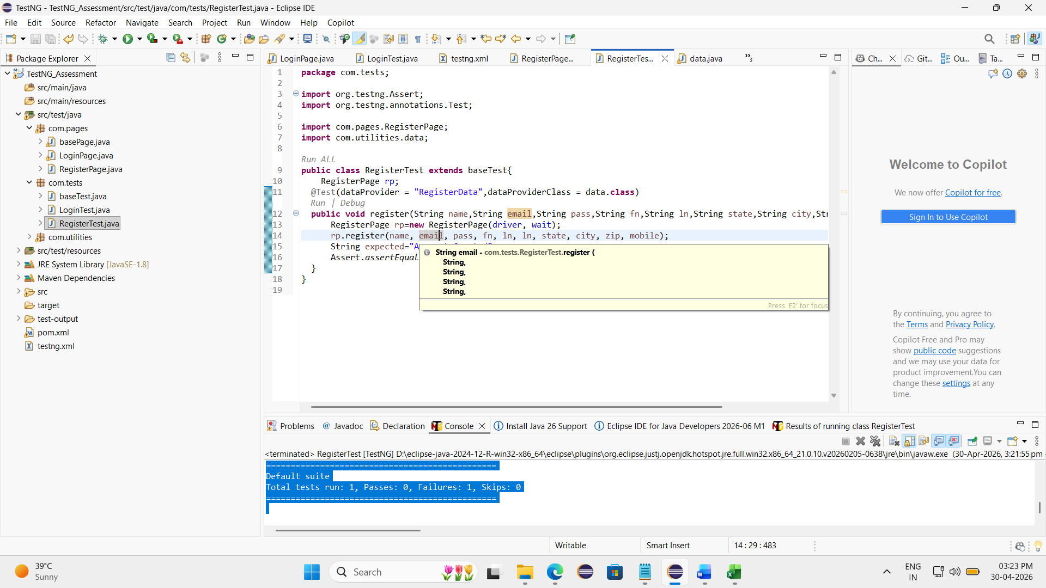

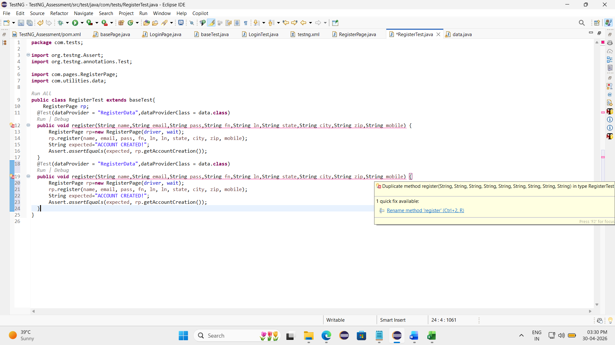

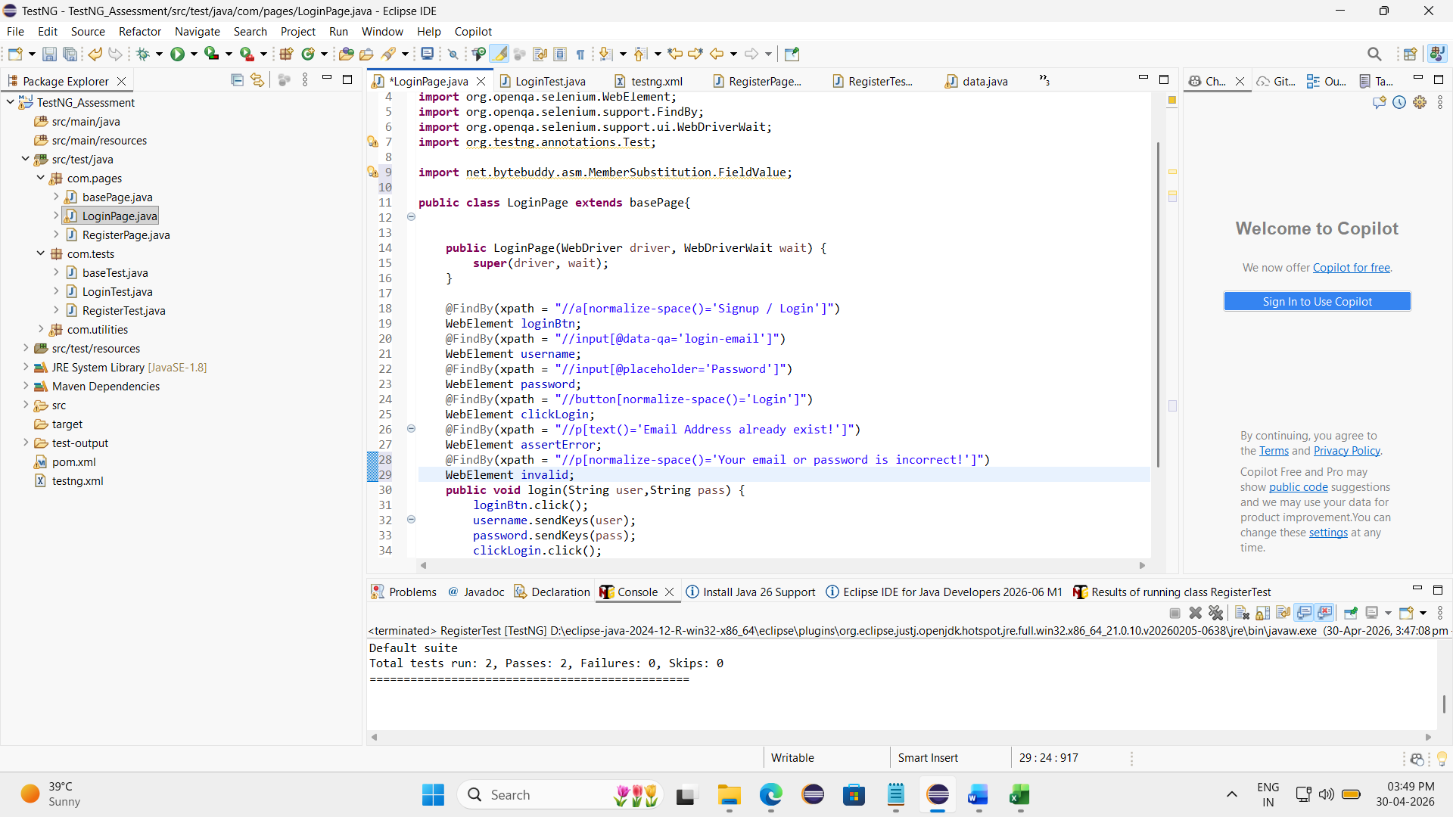

[RemoteTestNG] detected TestNG version 7.12.0
SLF4J(W): No SLF4J providers were found.
SLF4J(W): Defaulting to no-operation (NOP) logger implementation
SLF4J(W): See https://www.slf4j.org/codes.html#noProviders for further details.
FAILED: com.tests.LoginTest.login
org.testng.TestNGException:
Method public void com.tests.LoginTest.login(java.lang.String,java.lang.String) requires a @DataProvider named : LoginData
at org.testng.internal.Parameters.findDataProvider(Parameters.java:532)
at org.testng.internal.Parameters.handleParameters(Parameters.java:769)
at org.testng.internal.Parameters.handleParameters(Parameters.java:734)
at org.testng.internal.invokers.ParameterHandler.handleParameters(ParameterHandler.java:72)
at org.testng.internal.invokers.ParameterHandler.createParameters(ParameterHandler.java:51)
at org.testng.internal.invokers.TestInvoker$MethodInvocationAgent.invoke(TestInvoker.java:959)
at org.testng.internal.invokers.TestInvoker.invokeTestMethods(TestInvoker.java:203)
at org.testng.internal.invokers.TestMethodWorker.invokeTestMethods(TestMethodWorker.java:154)
at org.testng.internal.invokers.TestMethodWorker.run(TestMethodWorker.java:134)
at java.base/java.util.ArrayList.forEach(ArrayList.java:1596)
at org.testng.TestRunner.privateRun(TestRunner.java:744)
at org.testng.TestRunner.run(TestRunner.java:616)
at org.testng.SuiteRunner.runTest(SuiteRunner.java:421)
at org.testng.SuiteRunner.runSequentially(SuiteRunner.java:413)
at org.testng.SuiteRunner.privateRun(SuiteRunner.java:373)
at org.testng.SuiteRunner.run(SuiteRunner.java:312)
at org.testng.SuiteRunnerWorker.runSuite(SuiteRunnerWorker.java:52)
at org.testng.SuiteRunnerWorker.run(SuiteRunnerWorker.java:95)
at org.testng.TestNG.runSuitesSequentially(TestNG.java:1274)
at org.testng.TestNG.runSuitesLocally(TestNG.java:1208)
at org.testng.TestNG.runSuites(TestNG.java:1112)
at org.testng.TestNG.run(TestNG.java:1079)
at org.testng.remote.AbstractRemoteTestNG.run(AbstractRemoteTestNG.java:115)
at org.testng.remote.RemoteTestNG.initAndRun(RemoteTestNG.java:293)
at org.testng.remote.RemoteTestNG.main(RemoteTestNG.java:91)

===============================================
Default test
Tests run: 1, Failures: 1, Skips: 0
===============================================

===============================================
Default suite
Total tests run: 1, Passes: 0, Failures: 1, Skips: 0
===============================================

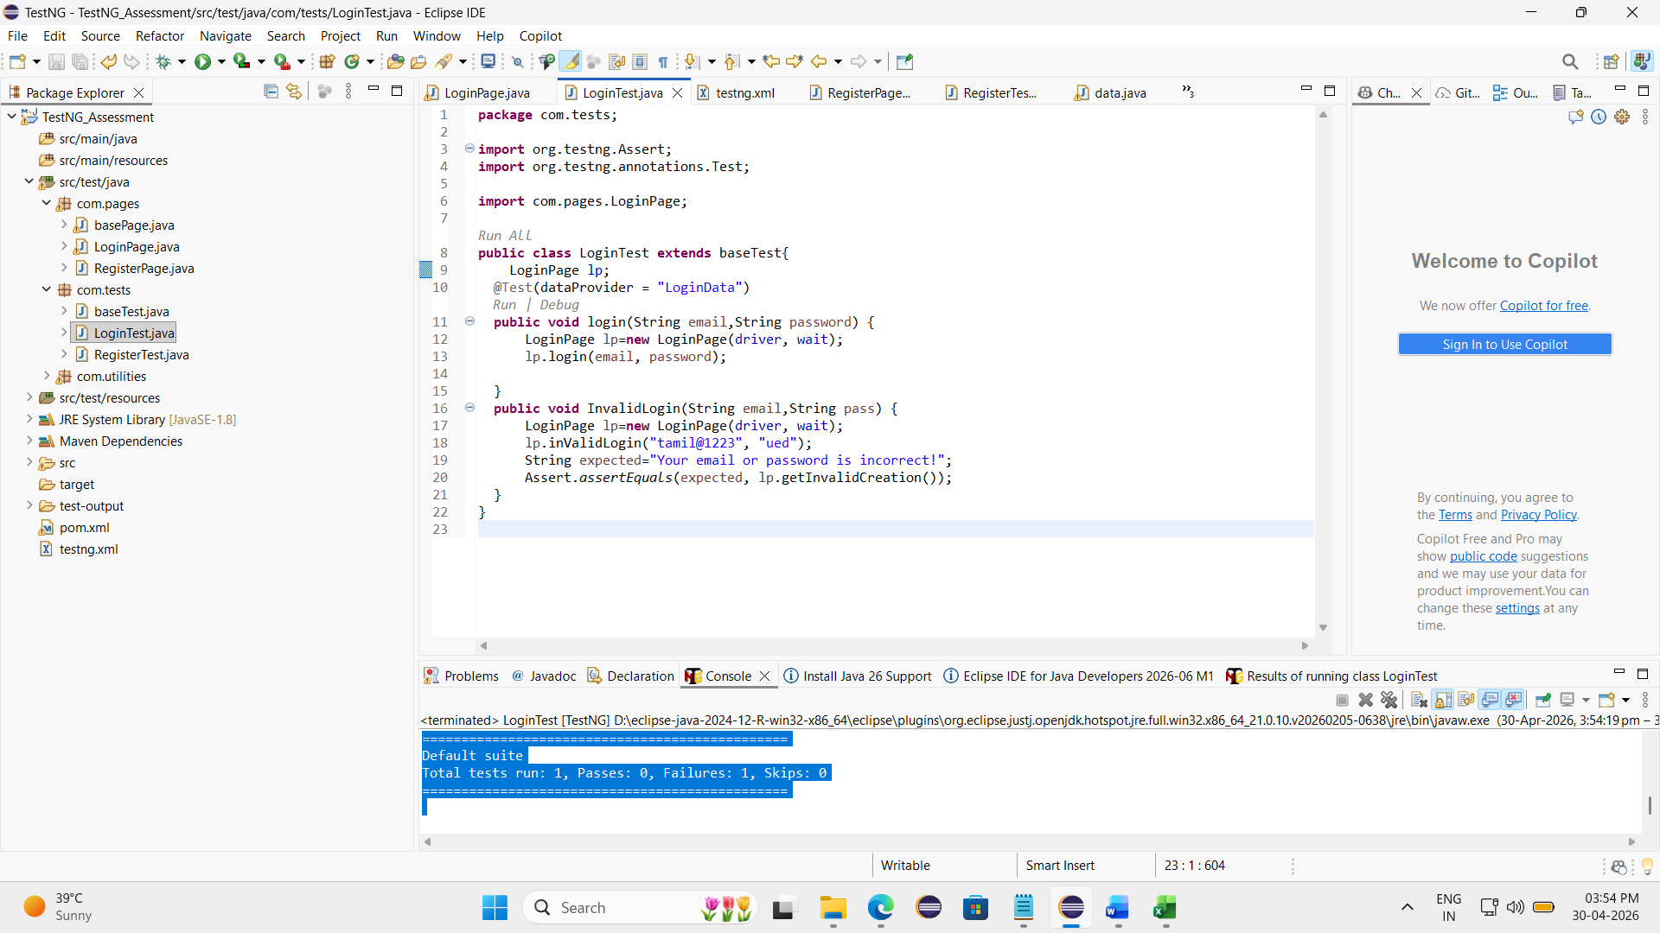

[RemoteTestNG] detected TestNG version 7.12.0
SLF4J(W): No SLF4J providers were found.
SLF4J(W): Defaulting to no-operation (NOP) logger implementation
SLF4J(W): See https://www.slf4j.org/codes.html#noProviders for further details.
FAILED: com.tests.LoginTest.login("tamilkumar@gmail.com", "Kiot1234")
org.openqa.selenium.NoSuchWindowException: no such window: target window already closed
from unknown error: web view not found
(Session info: chrome=147.0.7727.117)
Build info: version: '4.43.0', revision: 'dd0f534'
System info: os.name: 'Windows 11', os.arch: 'amd64', os.version: '10.0', java.version: '21.0.10'
Driver info: org.openqa.selenium.chrome.ChromeDriver
Command: [94adeb36f6e1ea23c35ab9e053551280, findElement {value=//input[@data-qa='login-email'], using=xpath}]
Capabilities {acceptInsecureCerts: false, browserName: chrome, browserVersion: 147.0.7727.117, chrome: {chromedriverVersion: 147.0.7727.117 (474cc805edd..., userDataDir: C:\Users\tamil\AppData\Loca...}, fedcm:accounts: true, goog:chromeOptions: {debuggerAddress: localhost:56110}, goog:processID: 13152, networkConnectionEnabled: false, pageLoadStrategy: normal, platformName: windows, proxy: Proxy(), se:cdp: ws://localhost:56110/devtoo..., se:cdpVersion: 147.0.7727.117, setWindowRect: true, strictFileInteractability: false, timeouts: {implicit: 0, pageLoad: 300000, script: 30000}, unhandledPromptBehavior: dismiss and notify, webauthn:extension:credBlob: true, webauthn:extension:largeBlob: true, webauthn:extension:minPinLength: true, webauthn:extension:prf: true, webauthn:virtualAuthenticators: true}
Session ID: 94adeb36f6e1ea23c35ab9e053551280
at org.openqa.selenium.remote.ErrorCodec.decode(ErrorCodec.java:169)
at org.openqa.selenium.remote.codec.w3c.W3CHttpResponseCodec.decode(W3CHttpResponseCodec.java:142)
at org.openqa.selenium.remote.codec.w3c.W3CHttpResponseCodec.decode(W3CHttpResponseCodec.java:49)
at org.openqa.selenium.remote.HttpCommandExecutor.execute(HttpCommandExecutor.java:223)
at org.openqa.selenium.remote.service.DriverCommandExecutor.invokeExecute(DriverCommandExecutor.java:216)
at org.openqa.selenium.remote.service.DriverCommandExecutor.execute(DriverCommandExecutor.java:174)
at org.openqa.selenium.remote.RemoteWebDriver.execute(RemoteWebDriver.java:606)
at org.openqa.selenium.remote.ElementLocation$ElementFinder$2.findElement(ElementLocation.java:166)
at org.openqa.selenium.remote.ElementLocation.findElement(ElementLocation.java:60)
at org.openqa.selenium.remote.RemoteWebDriver.findElement(RemoteWebDriver.java:429)
at org.openqa.selenium.remote.RemoteWebDriver.findElement(RemoteWebDriver.java:423)
at org.openqa.selenium.support.pagefactory.DefaultElementLocator.findElement(DefaultElementLocator.java:68)
at org.openqa.selenium.support.pagefactory.internal.LocatingElementHandler.invoke(LocatingElementHandler.java:38)
at jdk.proxy2/jdk.proxy2.$Proxy15.sendKeys(Unknown Source)
at com.pages.LoginPage.login(LoginPage.java:32)
at com.tests.LoginTest.login(LoginTest.java:14)
at java.base/jdk.internal.reflect.DirectMethodHandleAccessor.invoke(DirectMethodHandleAccessor.java:103)
at java.base/java.lang.reflect.Method.invoke(Method.java:580)
at org.testng.internal.invokers.MethodInvocationHelper.invokeMethod(MethodInvocationHelper.java:141)
at org.testng.internal.invokers.TestInvoker.invokeMethod(TestInvoker.java:697)
at org.testng.internal.invokers.TestInvoker.invokeTestMethod(TestInvoker.java:230)
at org.testng.internal.invokers.MethodRunner.runInSequence(MethodRunner.java:63)
at org.testng.internal.invokers.TestInvoker$MethodInvocationAgent.invoke(TestInvoker.java:1005)
at org.testng.internal.invokers.TestInvoker.invokeTestMethods(TestInvoker.java:203)
at org.testng.internal.invokers.TestMethodWorker.invokeTestMethods(TestMethodWorker.java:154)
at org.testng.internal.invokers.TestMethodWorker.run(TestMethodWorker.java:134)
at java.base/java.util.ArrayList.forEach(ArrayList.java:1596)
at org.testng.TestRunner.privateRun(TestRunner.java:744)
at org.testng.TestRunner.run(TestRunner.java:616)
at org.testng.SuiteRunner.runTest(SuiteRunner.java:421)
at org.testng.SuiteRunner.runSequentially(SuiteRunner.java:413)
at org.testng.SuiteRunner.privateRun(SuiteRunner.java:373)
at org.testng.SuiteRunner.run(SuiteRunner.java:312)
at org.testng.SuiteRunnerWorker.runSuite(SuiteRunnerWorker.java:52)
at org.testng.SuiteRunnerWorker.run(SuiteRunnerWorker.java:95)
at org.testng.TestNG.runSuitesSequentially(TestNG.java:1274)
at org.testng.TestNG.runSuitesLocally(TestNG.java:1208)
at org.testng.TestNG.runSuites(TestNG.java:1112)
at org.testng.TestNG.run(TestNG.java:1079)
at org.testng.remote.AbstractRemoteTestNG.run(AbstractRemoteTestNG.java:115)
at org.testng.remote.RemoteTestNG.initAndRun(RemoteTestNG.java:293)
at org.testng.remote.RemoteTestNG.main(RemoteTestNG.java:91)

FAILED: com.tests.LoginTest.InvalidLogin
org.testng.TestNGException:
Cannot inject @Test annotated Method [InvalidLogin] with [class java.lang.String, class java.lang.String].
For more information on native dependency injection please refer to https://testng.org/#_dependency_injection
at org.testng.internal.Parameters.checkParameterTypes(Parameters.java:442)
at org.testng.internal.Parameters.createParametersForMethod(Parameters.java:347)
at org.testng.internal.Parameters.createParameters(Parameters.java:699)
at org.testng.internal.Parameters.handleParameters(Parameters.java:885)
at org.testng.internal.Parameters.handleParameters(Parameters.java:734)
at org.testng.internal.invokers.ParameterHandler.handleParameters(ParameterHandler.java:72)
at org.testng.internal.invokers.ParameterHandler.createParameters(ParameterHandler.java:51)
at org.testng.internal.invokers.TestInvoker$MethodInvocationAgent.invoke(TestInvoker.java:959)
at org.testng.internal.invokers.TestInvoker.invokeTestMethods(TestInvoker.java:203)
at org.testng.internal.invokers.TestMethodWorker.invokeTestMethods(TestMethodWorker.java:154)
at org.testng.internal.invokers.TestMethodWorker.run(TestMethodWorker.java:134)
at java.base/java.util.ArrayList.forEach(ArrayList.java:1596)
at org.testng.TestRunner.privateRun(TestRunner.java:744)
at org.testng.TestRunner.run(TestRunner.java:616)
at org.testng.SuiteRunner.runTest(SuiteRunner.java:421)
at org.testng.SuiteRunner.runSequentially(SuiteRunner.java:413)
at org.testng.SuiteRunner.privateRun(SuiteRunner.java:373)
at org.testng.SuiteRunner.run(SuiteRunner.java:312)
at org.testng.SuiteRunnerWorker.runSuite(SuiteRunnerWorker.java:52)
at org.testng.SuiteRunnerWorker.run(SuiteRunnerWorker.java:95)
at org.testng.TestNG.runSuitesSequentially(TestNG.java:1274)
at org.testng.TestNG.runSuitesLocally(TestNG.java:1208)
at org.testng.TestNG.runSuites(TestNG.java:1112)
at org.testng.TestNG.run(TestNG.java:1079)
at org.testng.remote.AbstractRemoteTestNG.run(AbstractRemoteTestNG.java:115)
at org.testng.remote.RemoteTestNG.initAndRun(RemoteTestNG.java:293)
at org.testng.remote.RemoteTestNG.main(RemoteTestNG.java:91)

===============================================
Default test
Tests run: 2, Failures: 2, Skips: 0
===============================================

===============================================
Default suite
Total tests run: 2, Passes: 0, Failures: 2, Skips: 0
===============================================



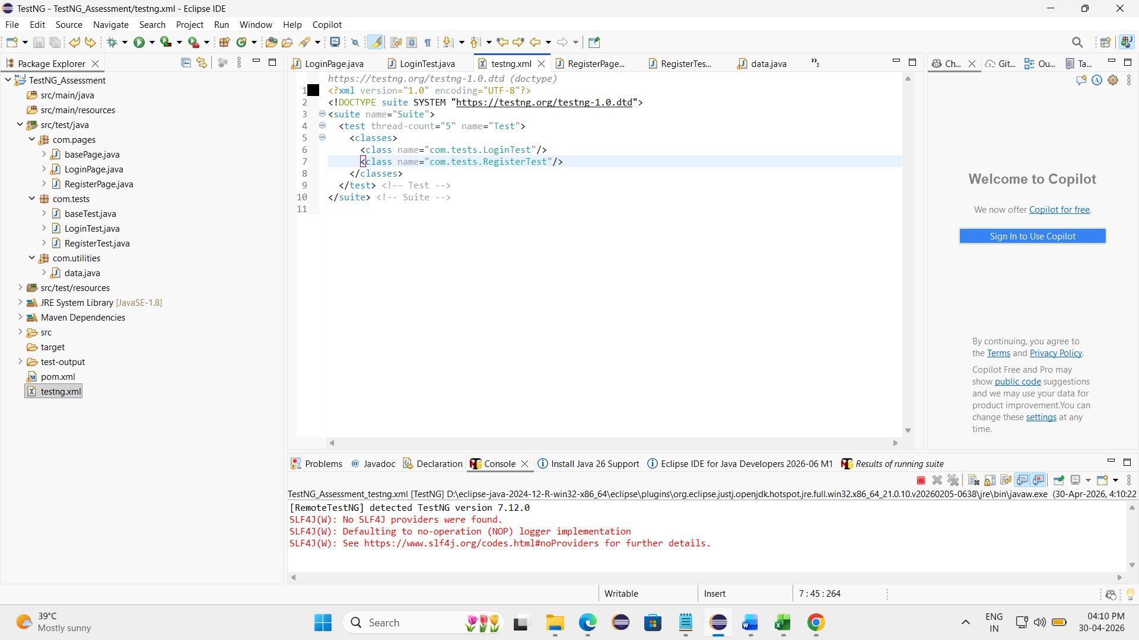

RemoteTestNG] detected TestNG version 7.12.0
SLF4J(W): No SLF4J providers were found.
SLF4J(W): Defaulting to no-operation (NOP) logger implementation
SLF4J(W): See https://www.slf4j.org/codes.html#noProviders for further details.

===============================================
Suite
Total tests run: 4, Passes: 4, Failures: 0, Skips: 0
===============================================
